Creating Keycloak for Authentication

keycloak:
base-url: ${KEYCLOAK_BASE_URL:http://localhost:9292}
realm: ${KEYCLOAK_REALM:restaurant-ktv-platform}
admin:
client-id: ${KEYCLOAK_ADMIN_CLIENT_ID:user-service}
client-secret: ${KEYCLOAK_ADMIN_CLIENT_SECRET:Ea0sBEuJkJSAt34JIIOYrXffbQEbSRSB}
login:
client-id: ${KEYCLOAK_LOGIN_CLIENT_ID:user-login}
client-secret: ${KEYCLOAK_LOGIN_CLIENT_SECRET:xUGbftWyuhAmlNciURkaWVO13sAl8GfT}

- Create realm
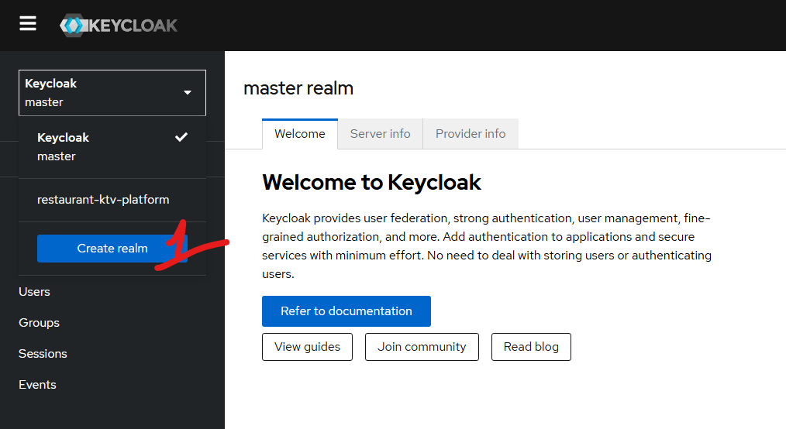

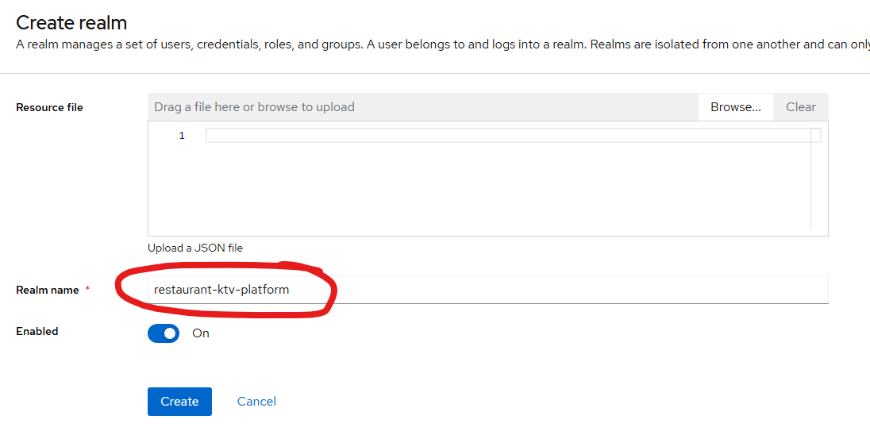

realm: ${KEYCLOAK_REALM:restaurant-ktv-platform}
បង្កើត two user : one is for create and update :
- user-service: for authentication
- user-login: for user login
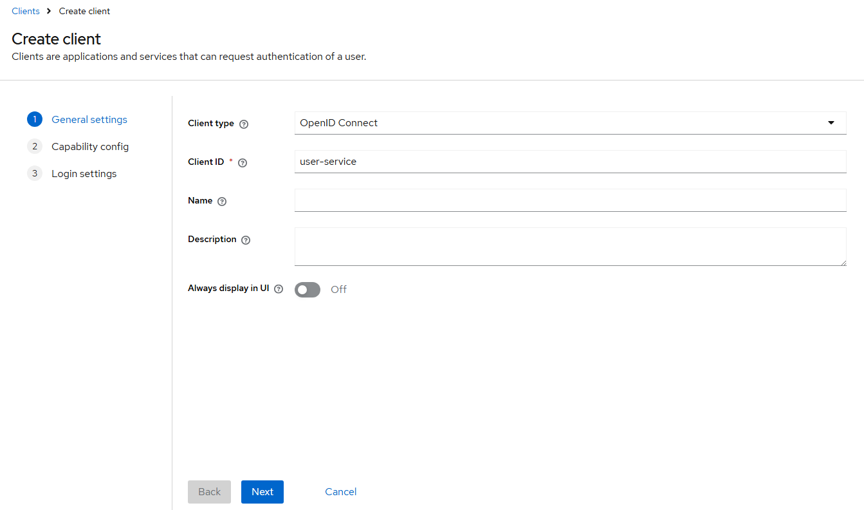

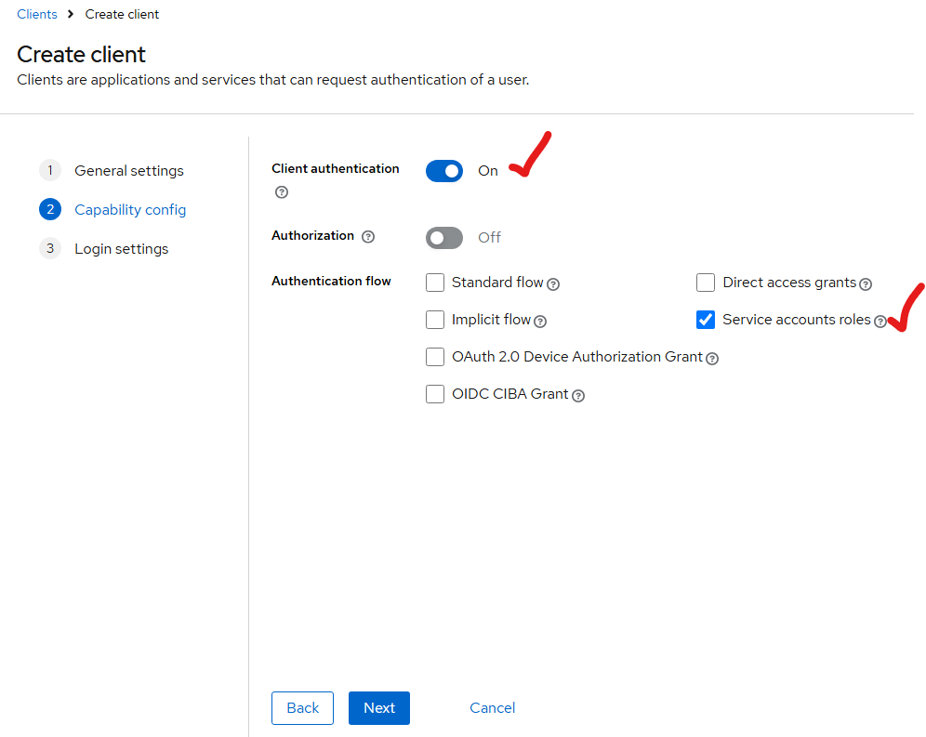

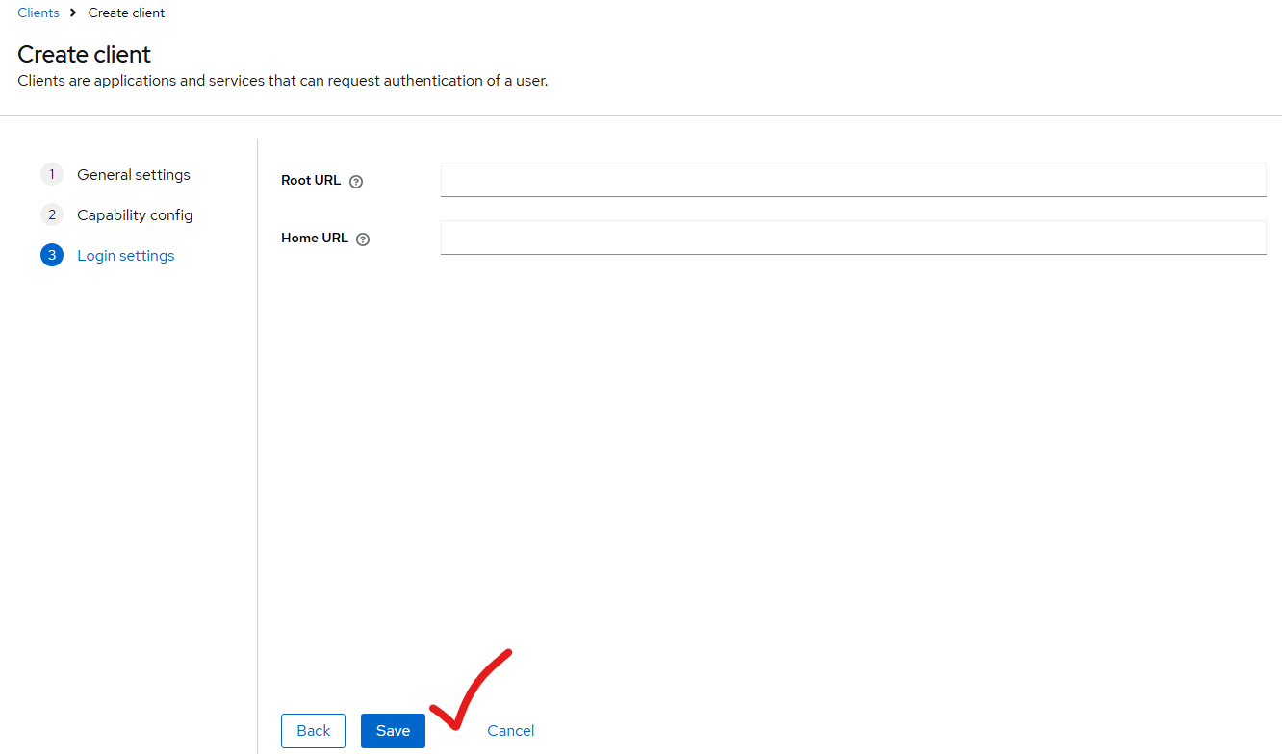

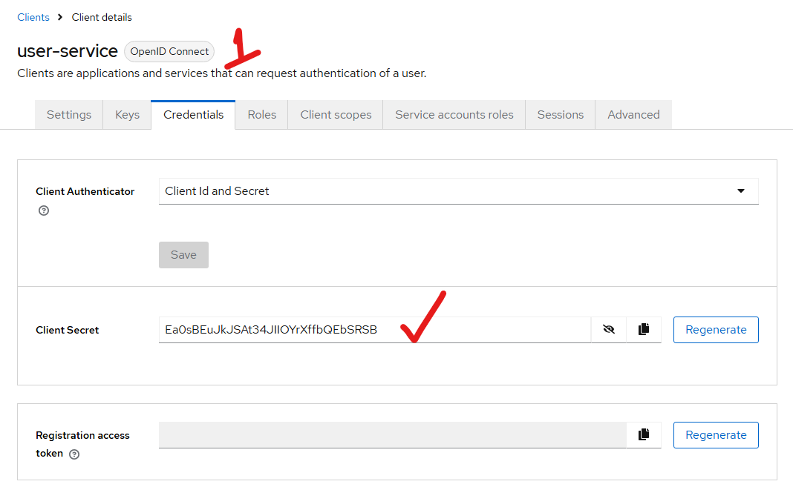

admin:
client-id: ${KEYCLOAK_ADMIN_CLIENT_ID:user-service}
client-secret: ${KEYCLOAK_ADMIN_CLIENT_SECRET:Ea0sBEuJkJSAt34JIIOYrXffbQEbSRSB}

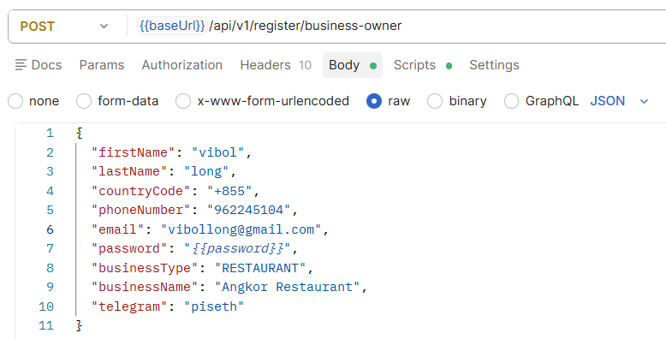

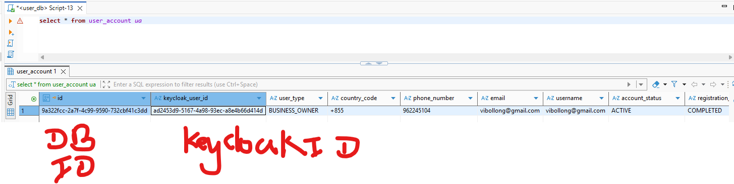

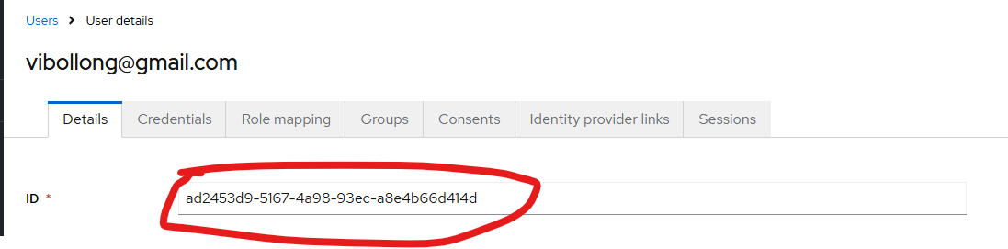

ចឹងមានន័យថា user-service : សេវាកម្មដើម្បីបង្កើត user
- then we will create user login

- create login

login:
client-id: ${KEYCLOAK_LOGIN_CLIENT_ID:user-login}
client-secret: ${KEYCLOAK_LOGIN_CLIENT_SECRET:xUGbftWyuhAmlNciURkaWVO13sAl8GfT}

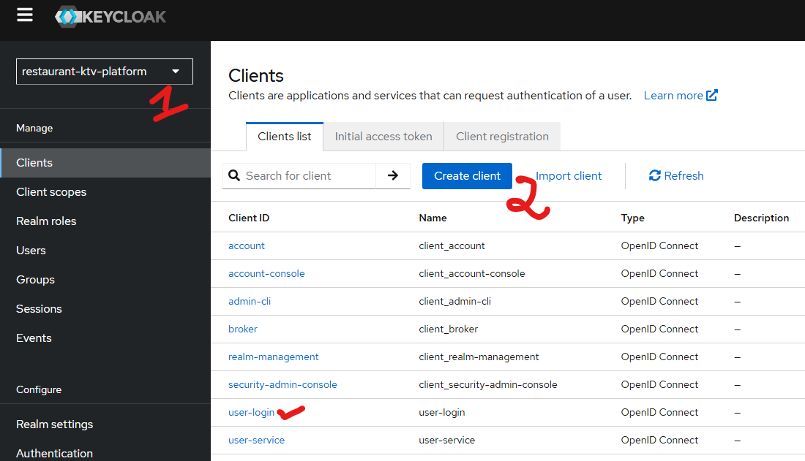

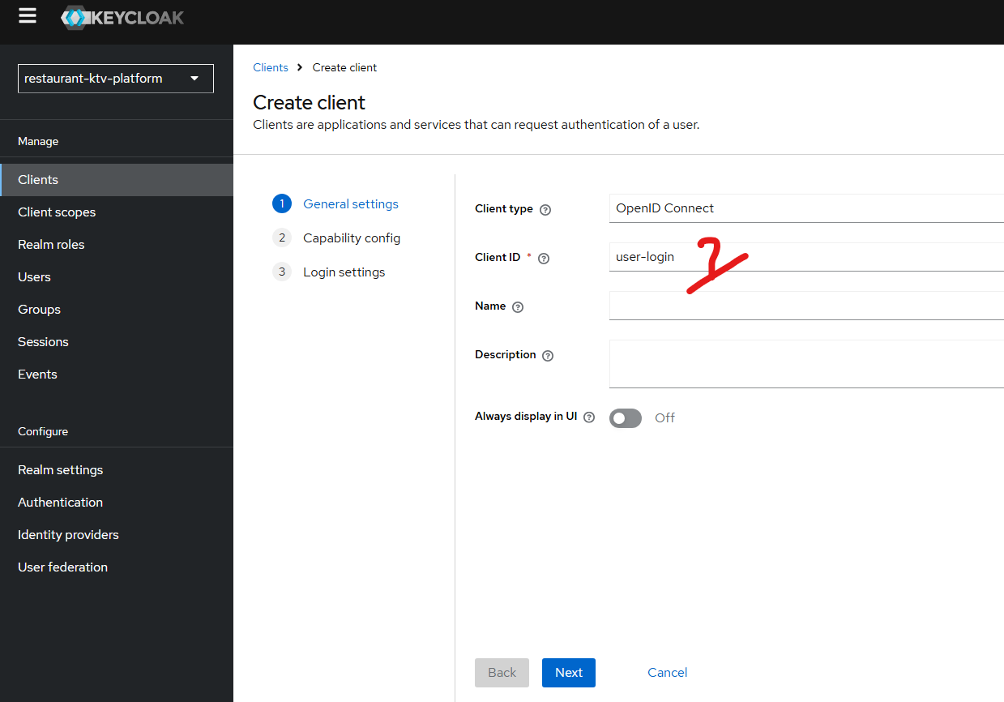

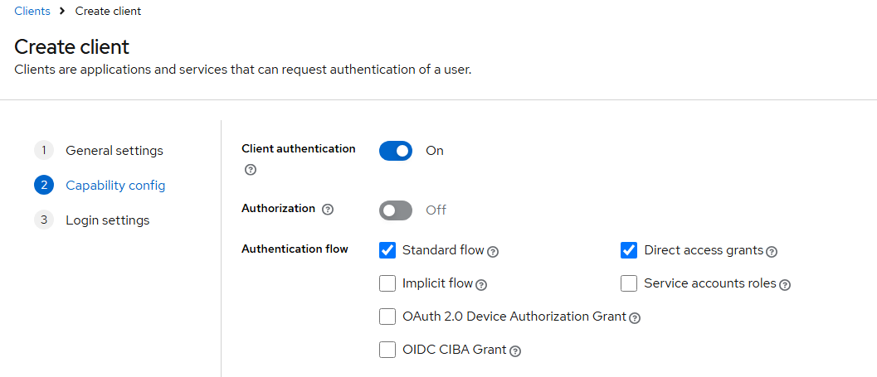

Then save after copying the credential to put our application.yml

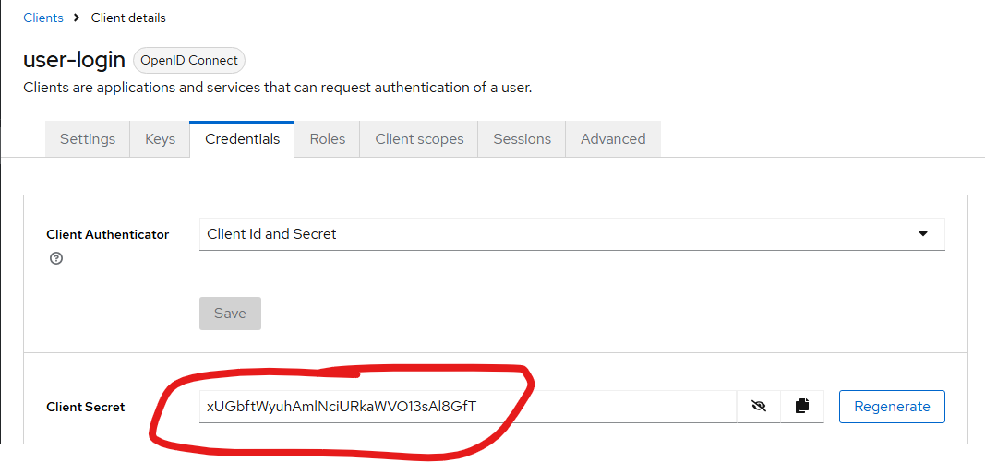

- then we get the access token and refress tokean

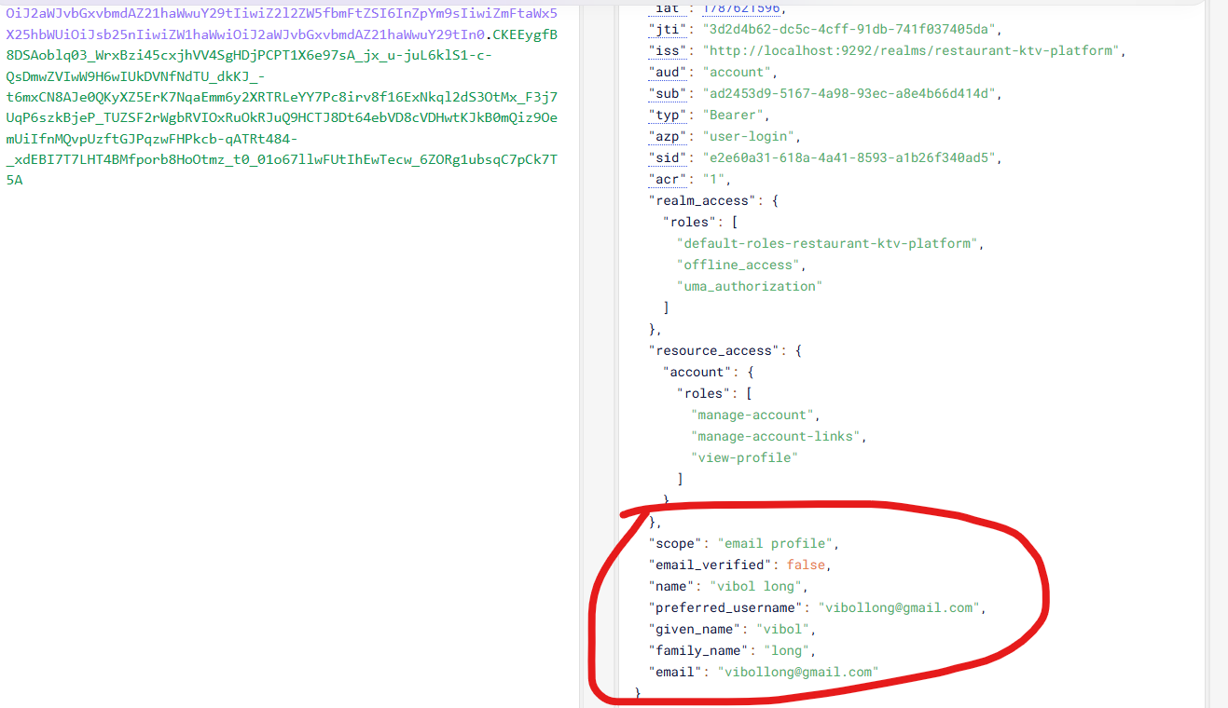

Then next step we will add the id to the scope to make the other system can access it.

